

**SOP (Standard Operating Procedure) for UART STM32F413ZHT6**



1. **Bench Setup Testing Procedure**

HARDWARE REQUIREMENTS:

1. USB to TTL

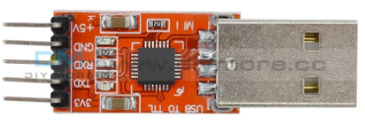

1. Jumper Cables (Female to Female)

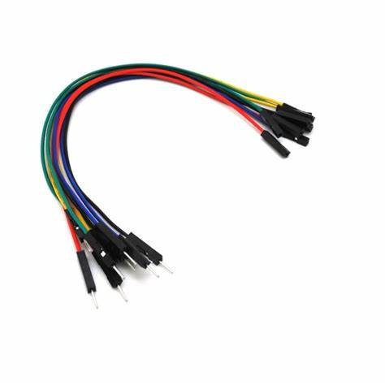

1. **Setup Hardware Connection:**
2. TTL Connection Pin Tx is connected to Usart3 Rx(PD9)
3. TTL Connection Pin Rx is connected to Usart3 Tx(PD8)

PD8

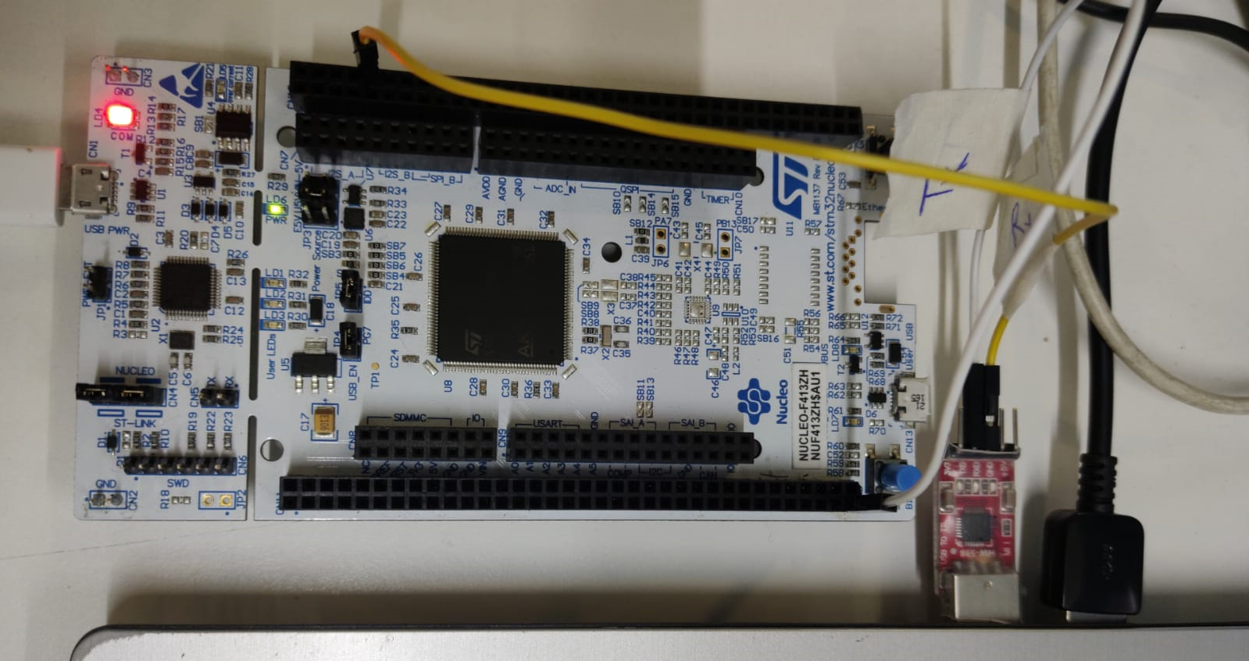

TTL

PD9

1. **Firmware Update Steps:**

* **STM32CUBEIDE:**
* **Steps in Configuring STM32 UART Communication Protocol**

**STEP 1 – Open Cube IDE and Create a new Project**

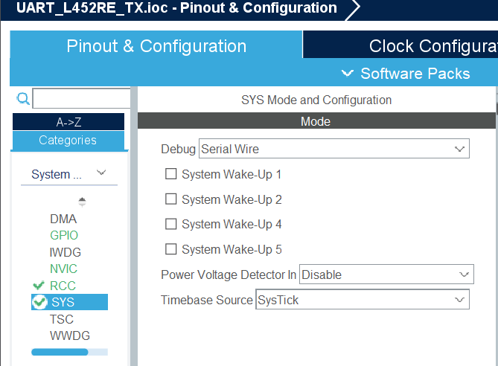

**STEP 2 – Configure SYS as Serial Wire and RCC as Crystal Ceramic Resonator**

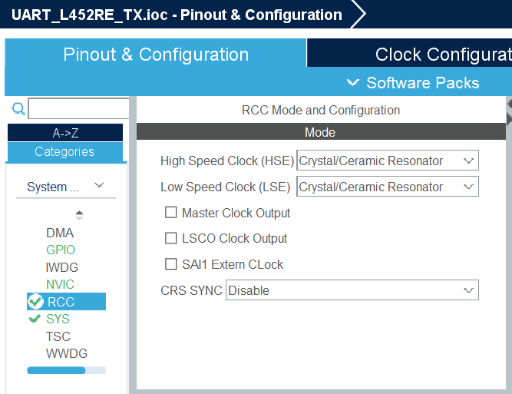

1. **UART Configuration Steps:**
2. Open connectivity click USART3
3. Mode = Asynchronous
4. Pin Configuration PD9(Rx) and PD8(Tx)
5. **Configuration** tab and set **Word Length** to **8 Bits**, baud rate to **115200 Bits/s**, **Parity** to **None**and **Stop Bits** to **1**

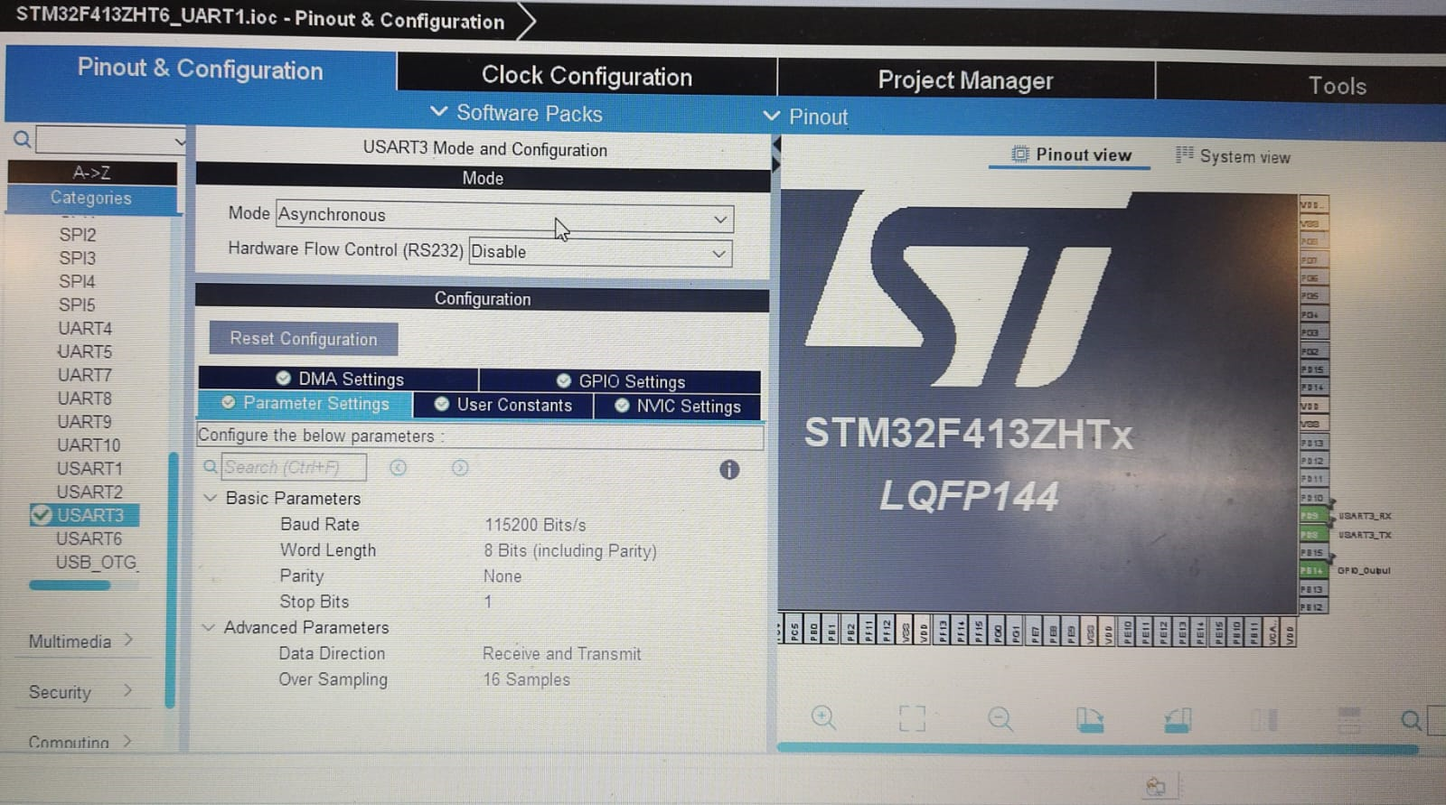

**UART CODE:-**

**In the main.c file write the code for UART Transmission and Build and if no errors are present run the Code.**

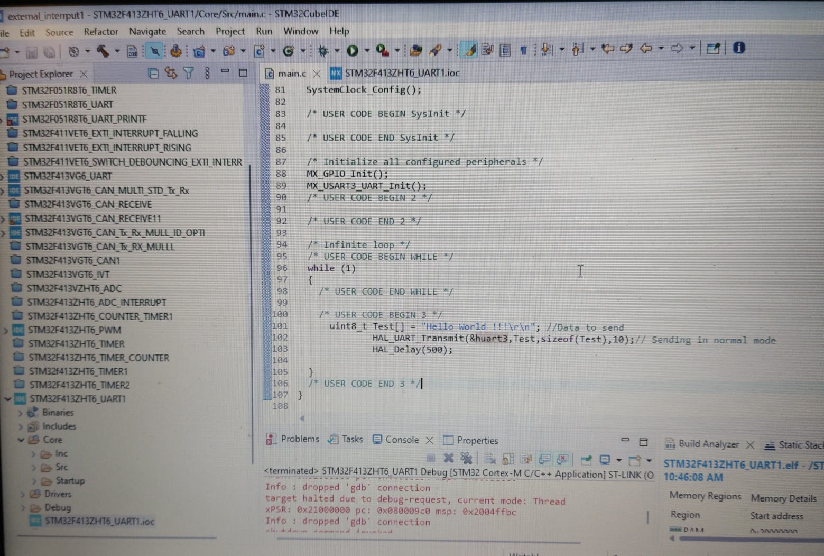

* **USART Initialisation :-**
  + MX_USART3_UART_Init();
    - In function initialization the UART
    - And configure about UART
    - Such as baudRate ,UART_WORLDLENGHT ,STOPBIT ,PARITY,ETC.
  + Insert the following lines in main function
  + In while(1) between **/* USER CODE BEGIN 3 */** and **/* USER CODE END 3 */**:

uint8_t Test[] = "Hello World !!!\r\n"; //Data to send

HAL_UART_Transmit(&huart3,Test,**sizeof**(Test),10);

// Sending in normal mode

HAL_Delay(500);

* + Firstly, In we stored the string in array(test variable)
  + Then UART Transmit (&huart3 is UART_HandleTypeDef huart3)
  + We Test means we transmit the string which is stored in test variable
  + Then the size of the test which mean string size
  + And then delay to transmit the data
  + The output Which can be check on Docklight through using TTl

1. **Check updated firmware on serial monitor.**

* **Dock light:**
* **Steps to Install Dock-light Software**

**Step 1 – Open Google and Type Download Docklight for Windows. Click on the following link.**



**Step 2 – Once Docklight Website Opens, Select Download Docklight Option as shown in the figure**

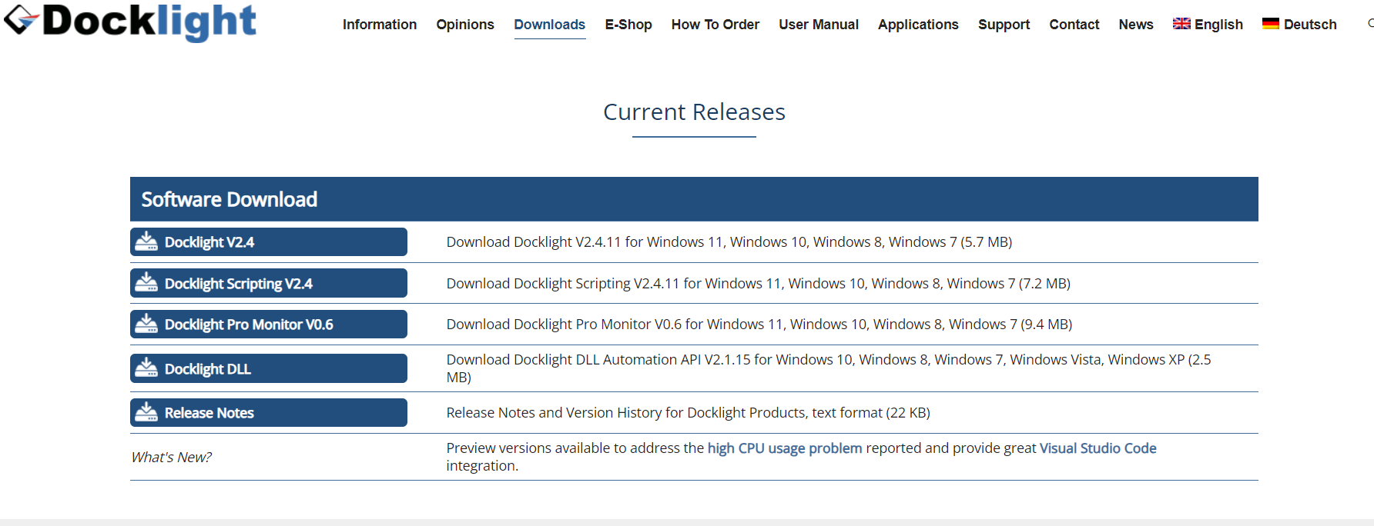

**Step 3 – Once Docklight Software is Downloaded, Install the Software. Click Run as Administrator.**

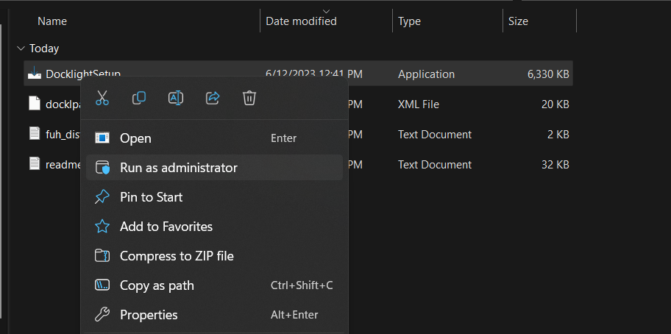

**Step 4 – Setup Docklight. Click Next**

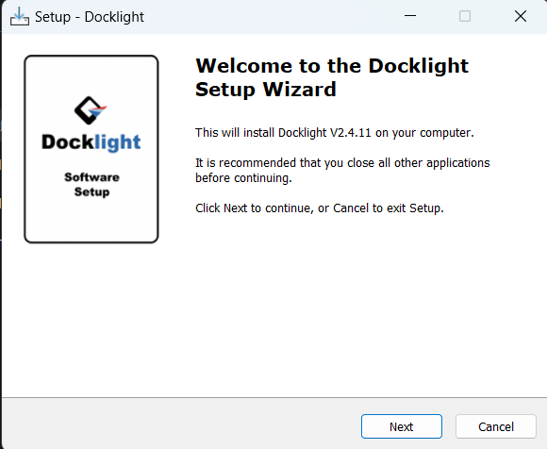

**Read Agreement and Click Next**

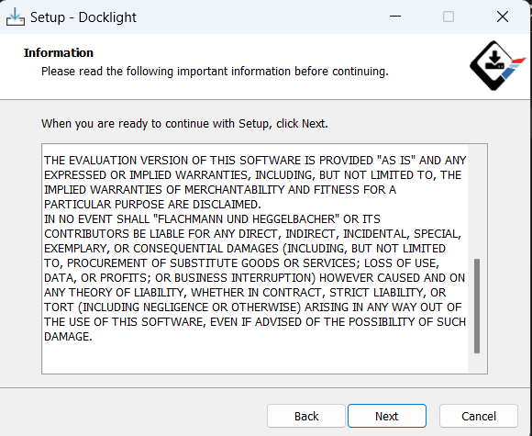

**Specify Folder for Installation. Keep the Default Folder and Click Next**

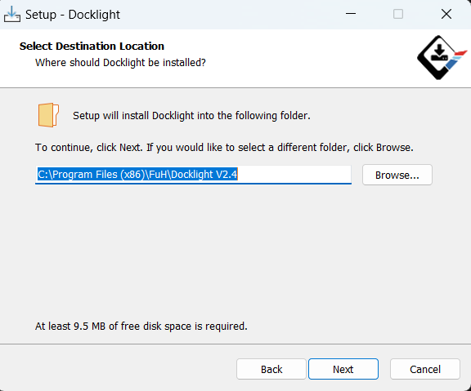

**Click Next**

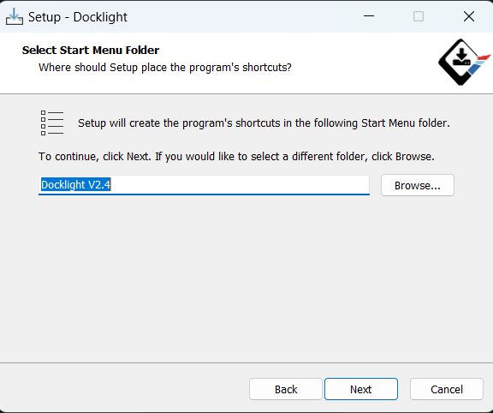

**Check on Create Desktop icon and Click Next**

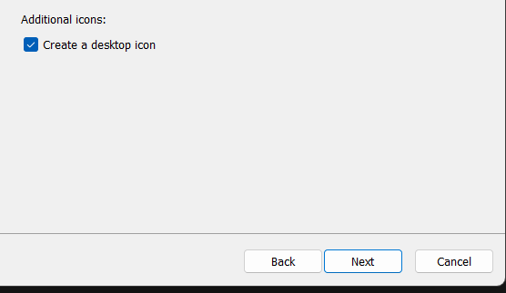

**Install the Application**

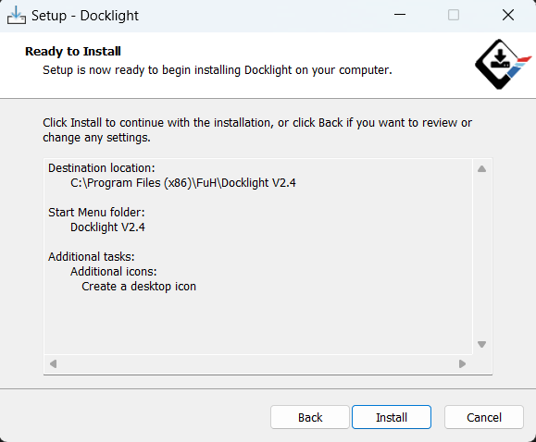

1. STM32F413ZHT6 Board interface with dock light software.
2. UART Connection (USB TTL):

In which the Tx(PD9) of board is connected to Tx of USB TTL And Rx(PD8) is connected to Rx of USB TTL.

1. Terminal Sequence:

* Baud rates: Set the baud rates as per requirements. (We can use 115200)
* Comport: Select the com1 port Serial Terminal.

1. We required USB to TTL driver installing our laptop or PC to run this Software.
2. **Open the Dock light Software.**

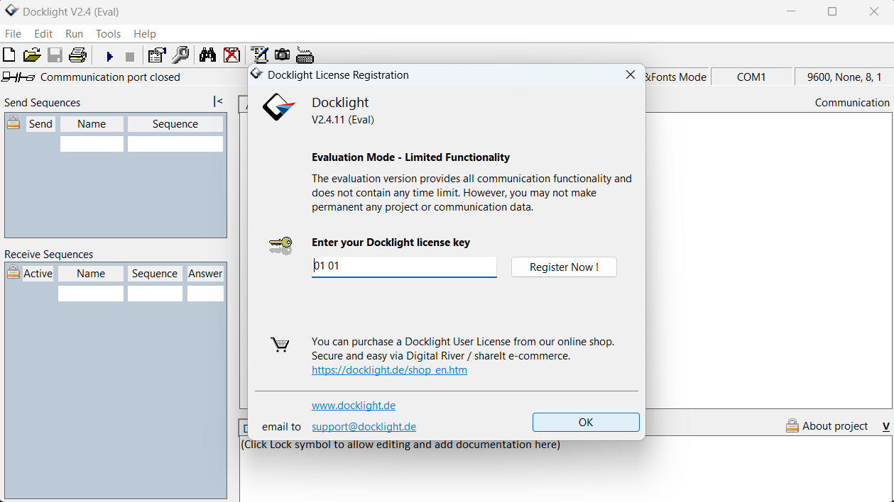

1. **Select the desired COM Port and Select the Baud Rate to 115200 BPS**

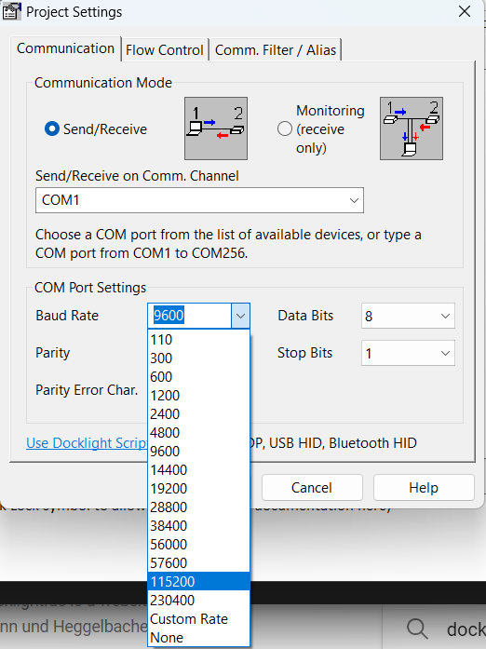

**Click on Run Button**



1. **Check the UART output in Docklight:-**

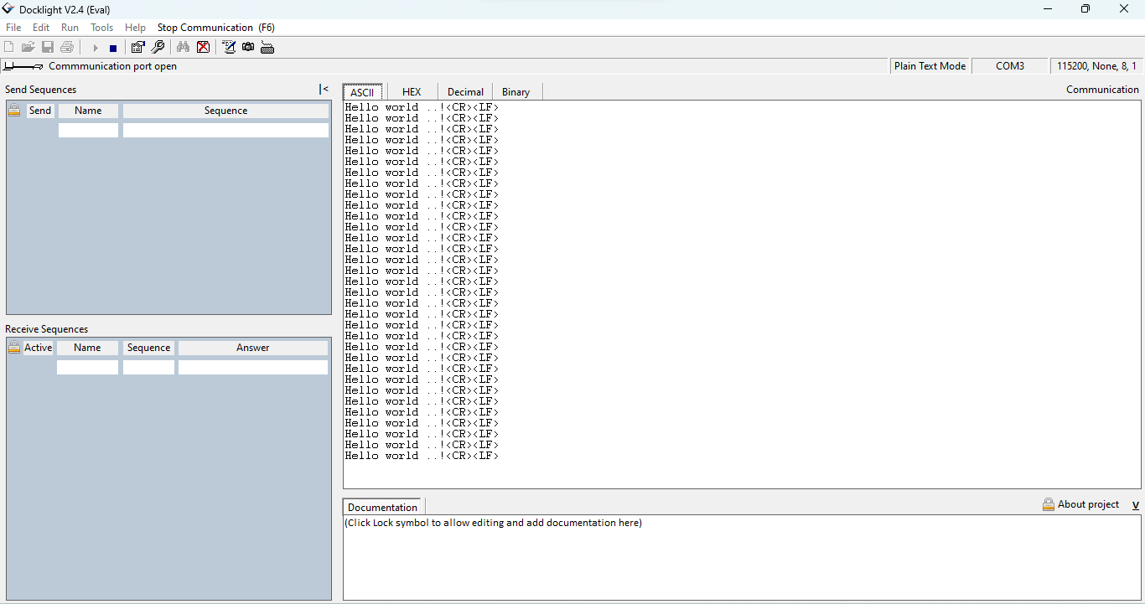

* **Printf using UART Initialisation :-**
* **Configuration is same such as UART**
* **Project manager -> Code Generator -> Generated files -> click Generate peripheral initialization as a .c /.h files per peripheral**

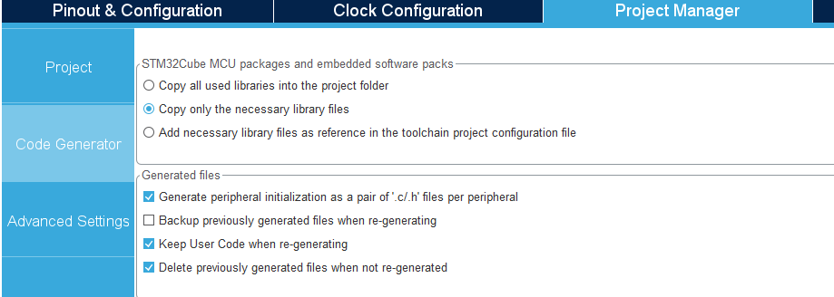

* **Click Project Manager then click Advance Settings -> USART -> Select -> LL then save**

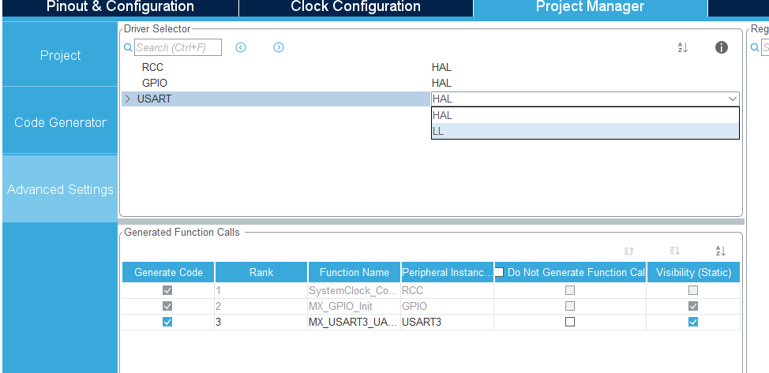

* **Difference is that when we printf function in program so every time we cannot write UART function**
* **Just we write only printf function** 
  + **E.g :-**
    - **printf(“Hello World \r\n”);**

**Step 1) Check your mail then download the zip file Debug_printf .c and .h file**

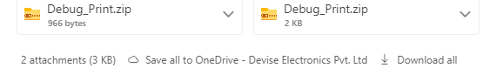

**Step 2) Extract these .c and .h files and copy these file**

**Debug_Print .c file copy**

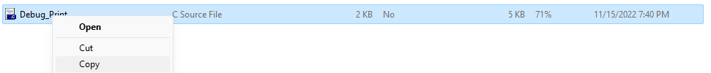

**Debug_Print .h file copy**

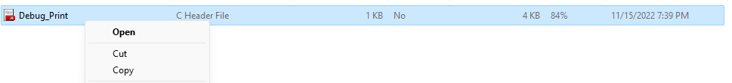

**Step 3) Debug_print.c in Core -> Src file then Paste**

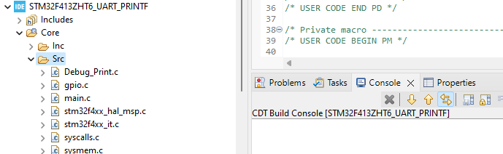

**Step 4) Debug_print.h in Core -> Inc file then Paste**

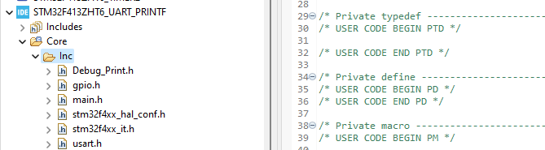

**Step 5) Add #include <stdio.h> to the Includes section at the top of the main.c file**

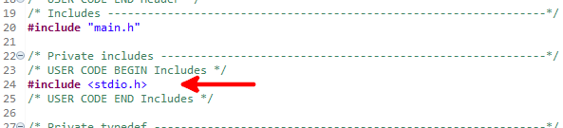

**Step 6) Open Debug_Print.h file Comment the line no 20 (**//#include "IoT_Platform_HAL/Include/USART_HAL_Driver.h") and add in line 27 **#define** UART_TTL USART3 **(check your USART which you initialize )**

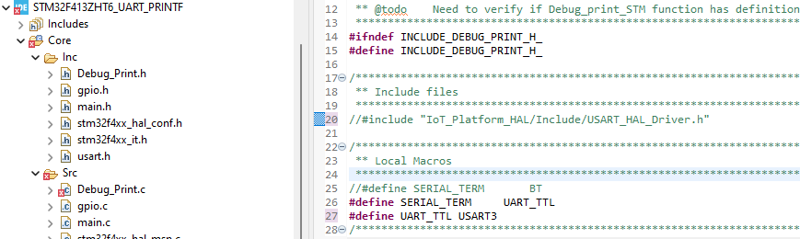

**Step 7) Open Debug_Print.c file delete line no 28 Include/**

**#include** "Debug_Print.h"

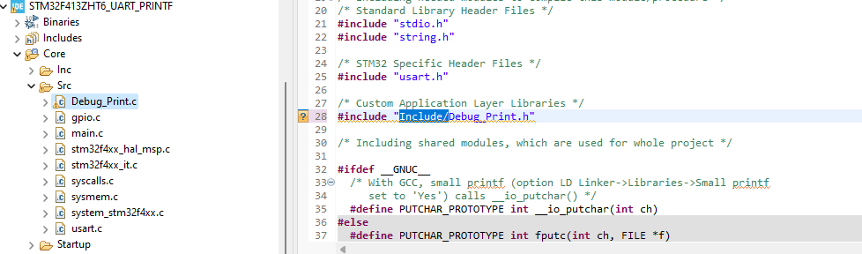

**Step 8) We can use printf function in your code just like**

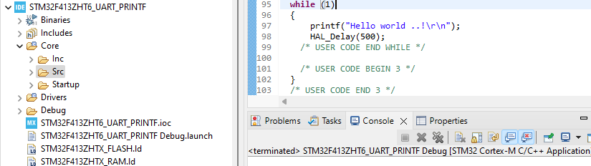

**Step 9) Check the Printf output in Docklight**

